Tap For Delicious

(Online Food Delivery Application)

# **Team Members**

Sravani Beemidi

Harika Bhemidi

# **Problem Statement:**

People are seeking for more ways to get things quickly and cheaply as industries grow. The manual method of purchasing groceries from local stores is becoming obsolete and time demanding. Customers must visit hotels or restaurants to learn about food items, then make an order and pay; this process takes time and requires manual labor. Customer does not have a physical copy of the menu item while placing an order over the phone, and there is no visual evidence that the order was done successfully. To provide a rich eating experience and collect payments, every restaurant needs certain personnel to take orders over the phone or in person. In today's market, labor rates are steadily rising, making it difficult to locate workers when they are needed. As a result, extensive public relations as well as the ability to order, process, and distribute food directly through an internet system are required.

# **Solution**

***Tap For Delicious*** app is an online meal delivery application that allows establishments to sell their food over the internet. The system streamlines the ordering procedure for both the customer and the restaurant, as well as reducing restaurant workload. The system will also compute and show the final bill automatically, ensuring that the bills are ready to print without error because the information for that item will already be added.

# **Users and Stakeholders:**

The users and stakeholders for this application will be customers as it will allow them to order and get the required food delivered home.

# **Scope and list of features on the proposed application**

The scope of the application is a user can register, order the food, view the status of the order and cancel the order.

# **Prototypes Of Screens:**

**Login Page**

User Name:

Password:

New User? Register Here

**Registration Page**

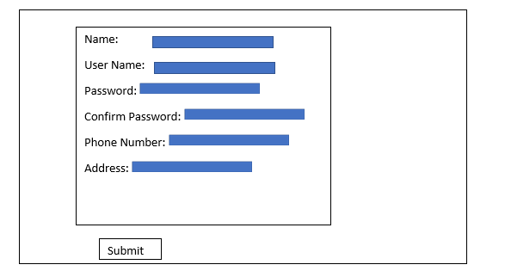

**Place Order**: Customer can Buy/Order here

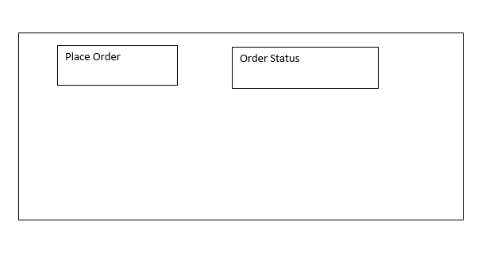

**Place Order**

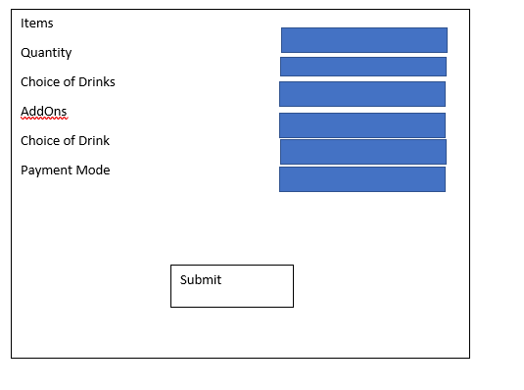

**Order Status**

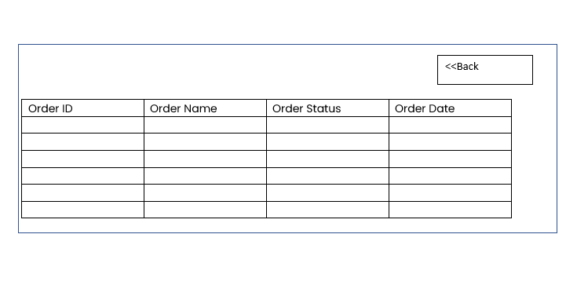

# **Conclusion**

Food ordering system application is real world problem, it is good example to implement as mobile application. The concepts learnt in the class can used in developing the food ordering system application. Overall, it also helps us to learn the process of mobile application development and implement the application